**Soundsensor Manual – Arduino**



The Sound sensor is basically just a Microphone that gives output if sound is discovered. The version in the image (which is the one I tested) has an Analog Output as well as a digital one. However, I only tested the Analog Output.

In this Example a LED will blink if sound is detected.

**Setup**

The setup is very basic and can be seen below. Notice that de sensor shown in the Image has only an Analog Output.

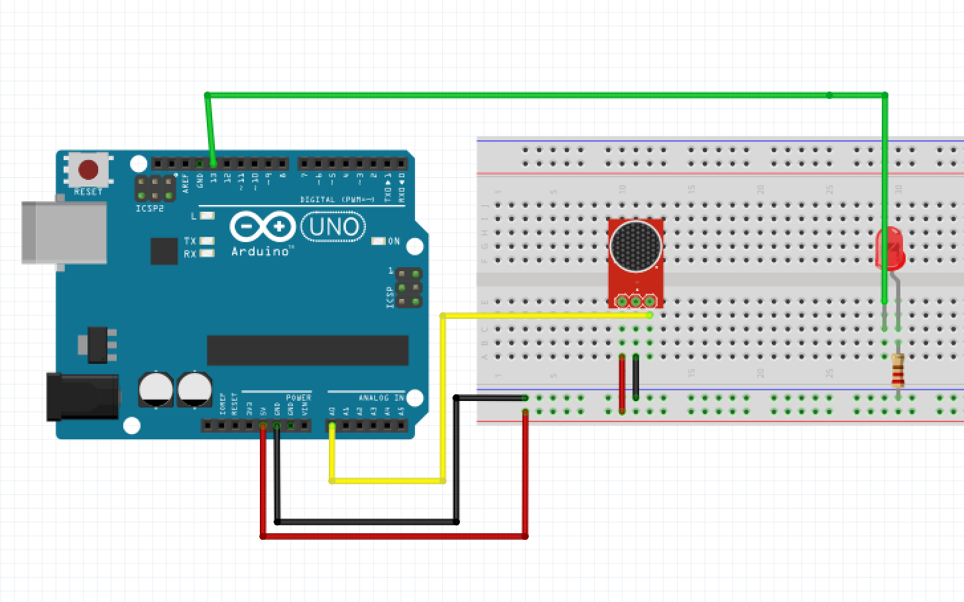

**Code**

int sensorPin = A0; // select the input pin for the Soundsensor

int ledPin = 6; // select the pin for the LED

int sensorValue = 0; // variable to store the value coming from the sensor

void setup ()

{

pinMode (ledPin, OUTPUT);

Serial.begin (9600);

}

void loop ()

{

sensorValue = analogRead (sensorPin);

Serial.println (sensorValue, DEC);

if (sensorValue < 257){

digitalWrite (ledPin, HIGH);

delay (sensorValue);

digitalWrite (ledPin, LOW);

delay (sensorValue);

Serial.println (sensorValue, DEC);}

}

(To better view the Code, look it up in the Frizzing-File)

**Notes**

On Average I got a signal of about 250 from the sensor in a room with 5 people working. A sound has to be pretty loud for it to be detected from the sensor, a clap for example has to happen right next to the sensor.